INEQUALITY WITHIN OUR WORLD
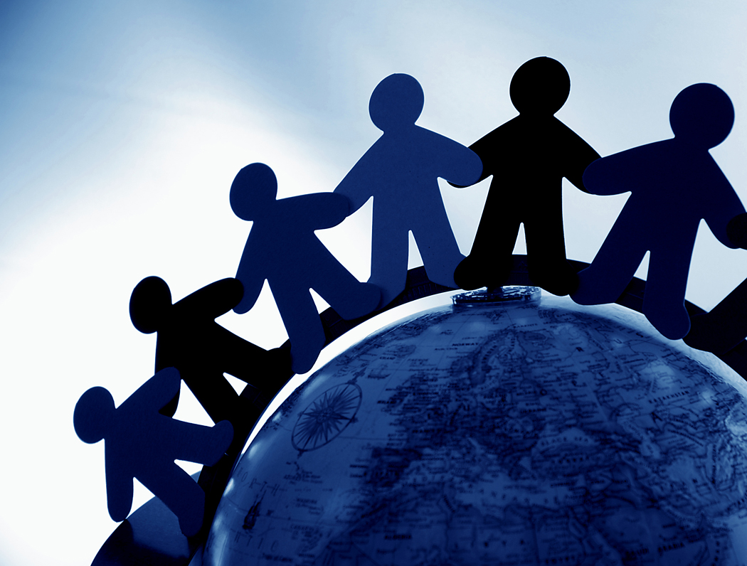
LESS SERIOUS
VERY SERIOUS
SERIOUS

Education

Wealth

Race

Shelter

Healthcare

Food

Water

Healthcare

Gender

